Task 1 :Create user with name Techie and provide sudo access to user
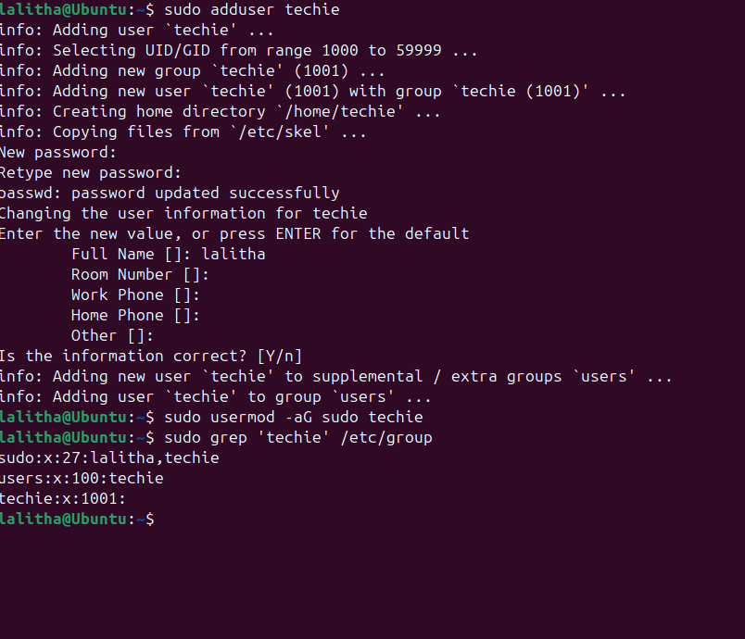
Step 1 : Create a new User
sudo adduser techie
This creates a new user named techie
Then its Asking me to set password, Done with password setup .
Step 2: Add the user to the sudo group
sudo usermod -aG sudo techie
This command added techie to the sudo group
Step 3: verify by using the command “ sudo grep ‘techie’ /etc/group

Task 2 . Navigate to the home Directory
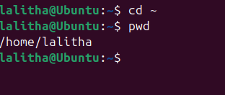
Step 1: cd ~
It Takes you to your home directory ( the ~ symbol represents your home).
Srep2 : pwd : present working Directory
It Shows your current location in the file system.
Task 3 : Create a new Directory & Task 4 : List the contents of a Directory
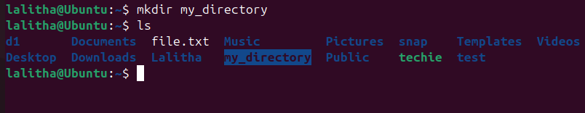
Step 1 : mkdir : stands for make directory.
In this case , I created a folder named “my_directory “ inside my current working directory
(/home/lalitha).
Step 2: To confirm I used “ls” command “ls “: list all files and Directories

Task 5 : Change the Current Directory
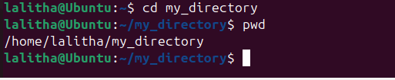
Step 1 : Change Directory
To change the directory I used “cd “ command followed by my Directory name
Then You moved inside the folder named my_directory that I created earlier.

Step 2 : Then I performed “ pwd “ command to check my exact path of my current location in the file system.
This Confirms me that Im inside the folder “my_directory” located in my home directory
/home/lalitha.
Task 6 : Create a New empty File
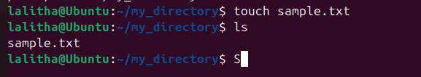
Step 1 : Create a new empty file
Here I Used touch command and the file name is sample.txt
The touch command is used to create a new empty file (size = 0 bytes)
If the file with that name already exists , It just updates its timestamp.
Step 2: To confirm the file was created I used “ ls” command it shows me list all files.
Task 7 : View the contents of a file
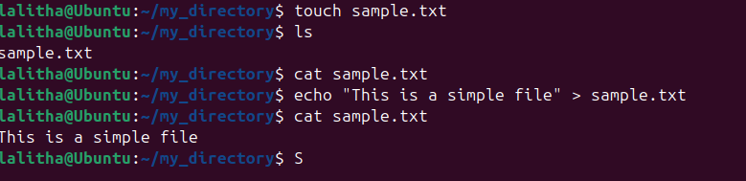
Step 1 : To view the content of a file I used “cat sample.txt” but the file is empty There is no content in sample.txt file
Step 2 : Then I add some content into file again if I use the command cat sample.txt it shows me the content
Task 8 : copy a file to another location
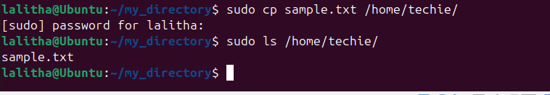
Step1 : sudo cp sample.txt /home/techie/
Here cp -> copy command , sample.txt -> the source file , /home/techie - > home direcytory
Sudo -> gives you admin rights , since you’re copying to another user’s home directory that needs elevated permission.
Step 2 : To verify the copied file
Sudo ls /home/techie/
The n it gives me “sample.txt” This confirms that the file was successfully copied.
Task 9 : Move a file to another location
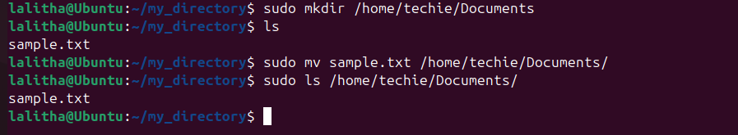
Step 1 : Created a Directory
Sudo mkdir /home/techie/Documents
Step 2 : Checked the currnt Directory
ls
Step3 : Moved File
Sudo mv sample.txt /home/techie/Documents/
Step 4 : To verify
Sudo ls /home/techie/Documents/
Task 10 : Rename a file
9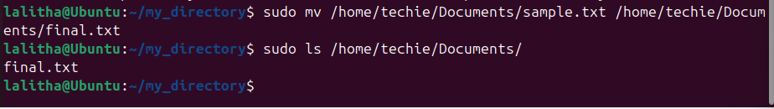
Step 1 : sudo mv /home/techie/Documents/sample.txt /home/techie/Documents/final.txt
mv command is used to rename the file
step 2 : To verify
sudo ls /home/techie/Documents/

Task 11 : Delete a file
To remove I used “rm” command
Sudo rm /home/techie/Documents/final.txt
Task : 12 : Grant or revoke permissions on a file or directory
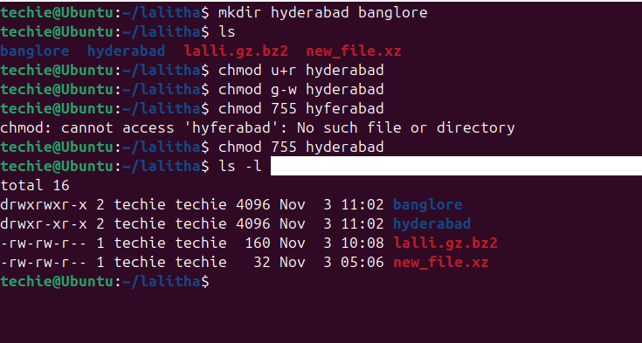
Task 13: View the current date and time
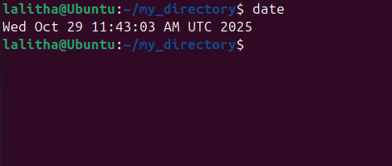
Task 14 : Check The System uptime
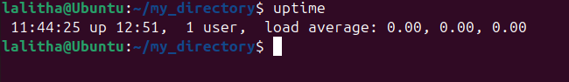
Task 15 : View the Running Processes
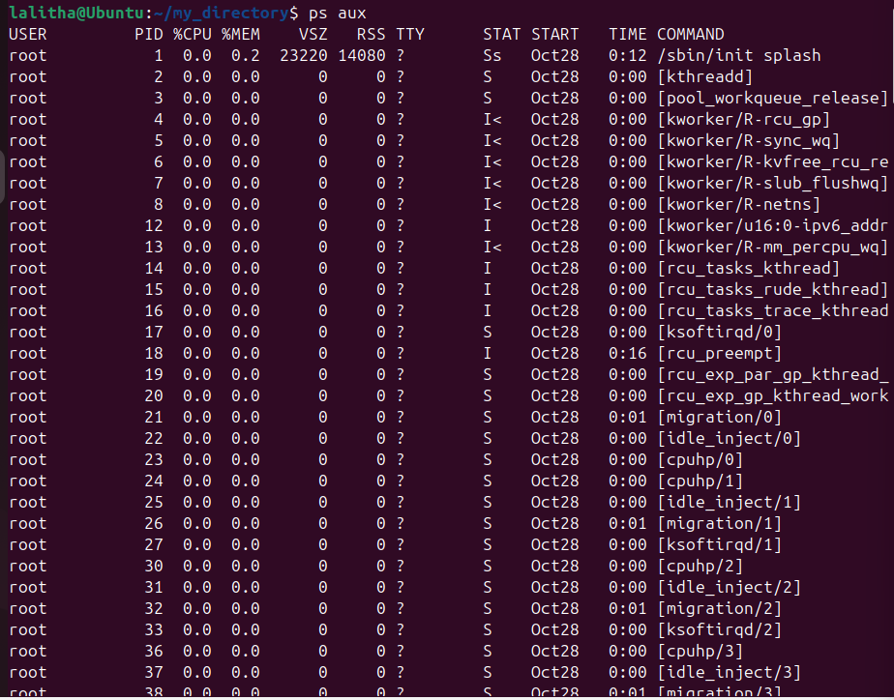
The “ps aux” command display the deatailed information about all running processes on my system.
Task : 16 Kill a Running process
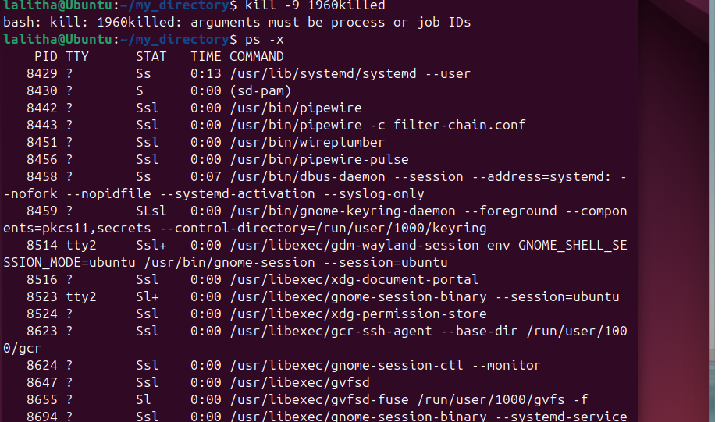
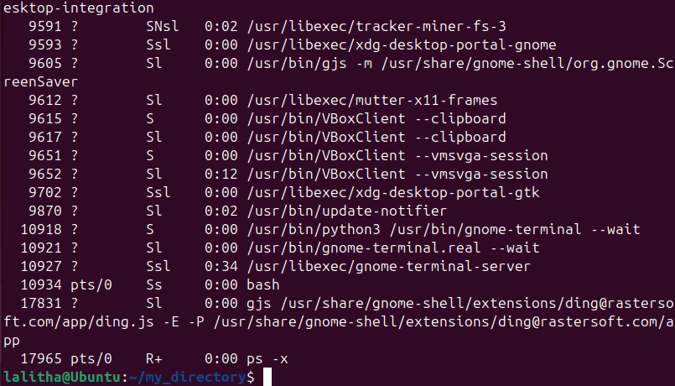
Task 17 : Install a package using the package manager (e.g., apt or yum).
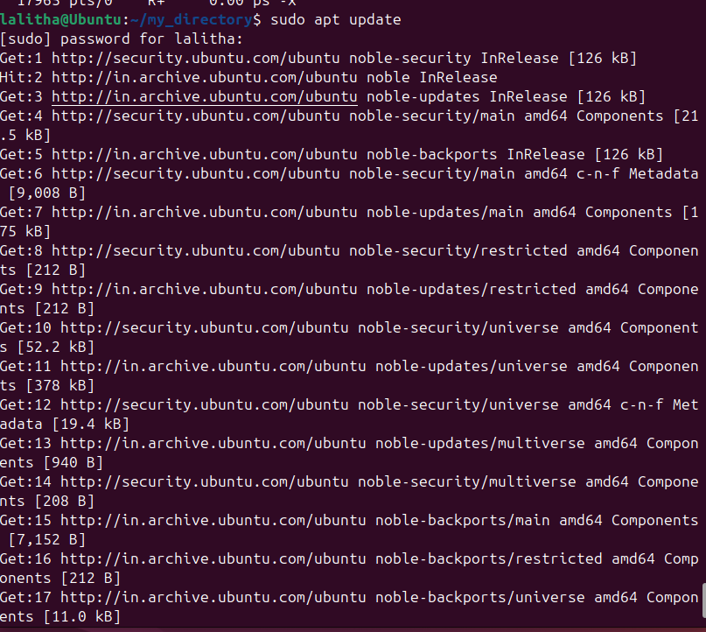
Step 1 : sudo apt update
This refreshes the list of available software and versions
Step 2: install a package
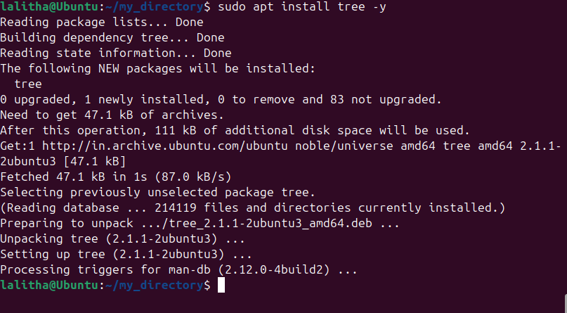
tree -> package name
-y -> automatically confirms installation
Step 3 : verify the installation
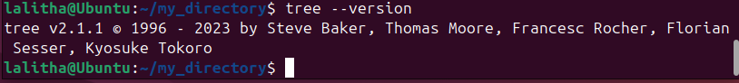
Task 18 : update the system packages
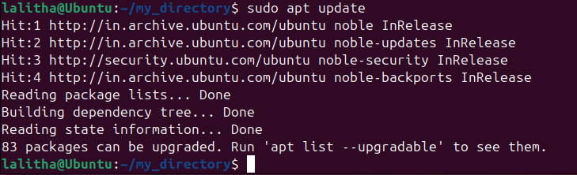
Step 1: update the package list
sudo apt update
This command fetches the latest lists of available updates (doesn’t install anything yet)
Step 2 : upgrade installed packages
Sudo apt upgrae -y
This command installs the latest versions of all currently installed packages
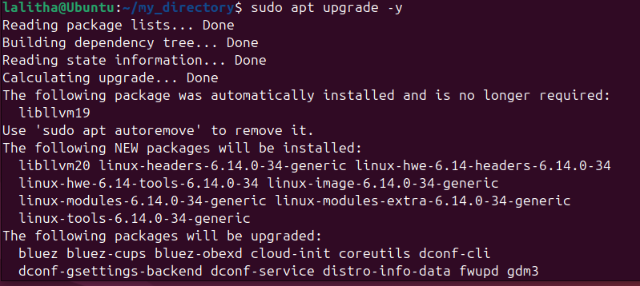
Step 3 : sudo apt full-upgrade -y
This command can remove old packages and install new dependencies as needed
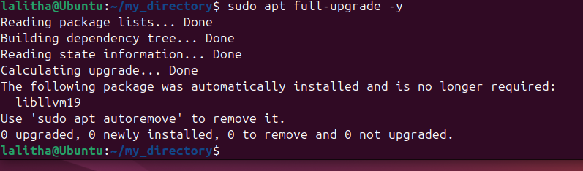
step 4: cleanup old cached files
sudo apt autoremove -y
sudo apt autoclean
This removes unnecessary packages and clears local cache to save space
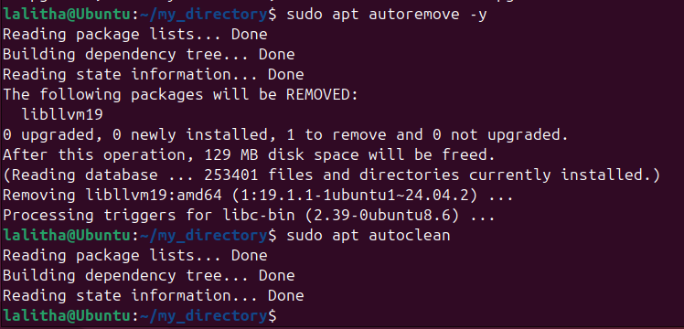
Task 19 : Create a Symbolic link
This command creates a new file original.txt in the /home/techie/Documents/
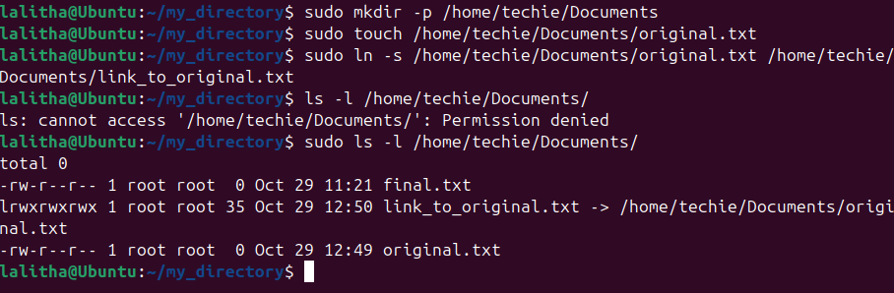
Task 20 :Search for files using the find command
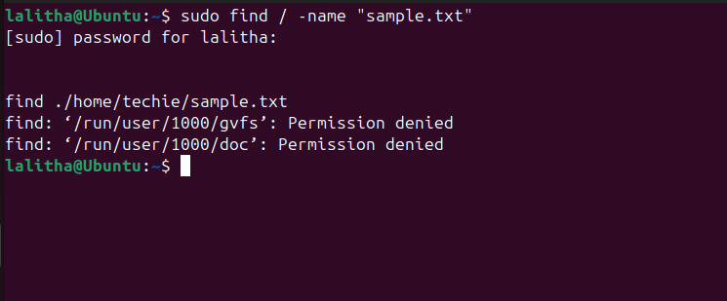

Here sudo -> runs the command with superuser privillages (gives access to all system directories)
/ -> searches from the root directory
-name “sample.ttx” -> looks for files with the exact name sample.txt
Task 21: Compress and Decompress Files using tar
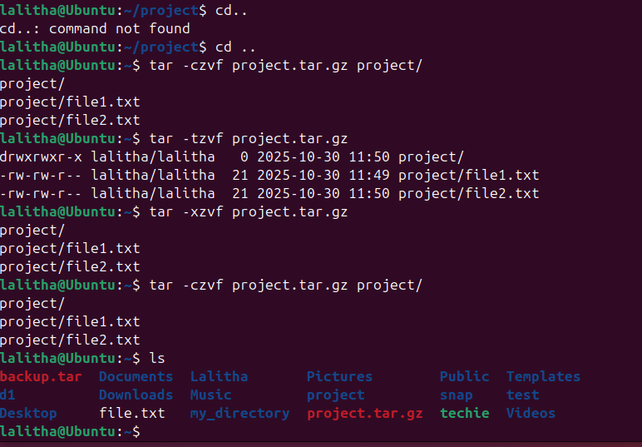

mkdir project
cd project
echo "Hello, this is file1" > file1.txt
echo "Hello, this is file2" > file2.txt
cd ..
Step2 :
tar -czvf project.tar.gz project/
- c → Create archive
- z → Compress with gzip
- v → Verbose (show files being added)
- f → File name
This will create a file called project.tar.gz in your current directory.

tar -tzvf project.tar.gz
tar -xzvf project.tar.gz
Then I used ls command to confirm
Task 22: Monitor System Resources with top or htop
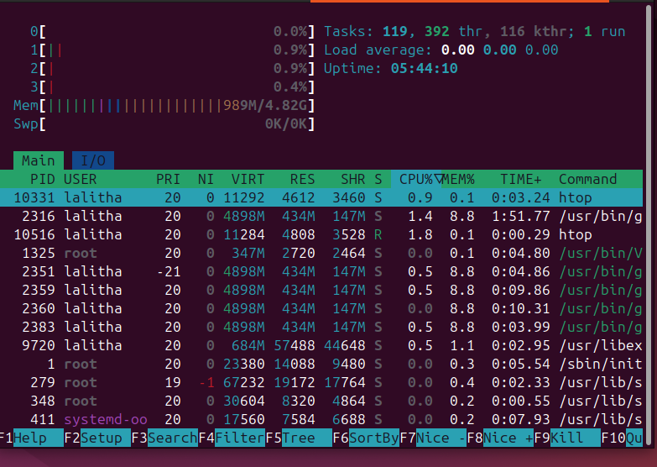
Using -> sudo apt install htop -y
Then htop
Task 23: Create and Manage User Groups

sudo groupadd devops
sudo usermod -aG devops Techie
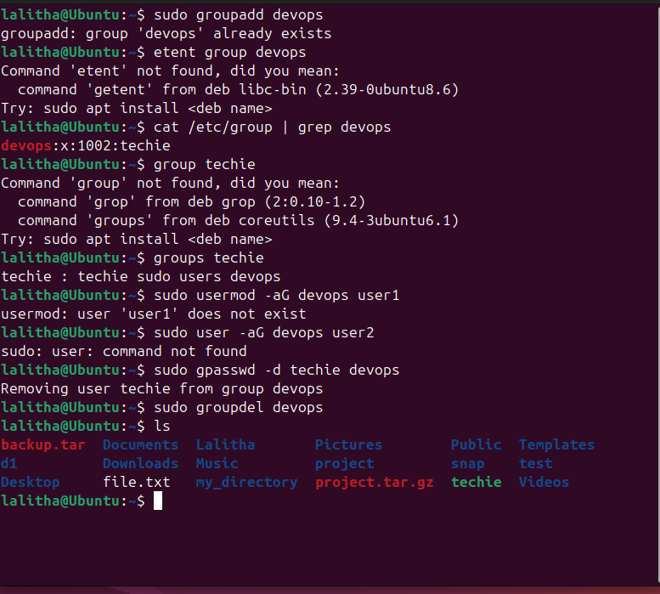
groups Techie
Creates group and adds a user to it.
Task 24: setup SSH password less Authentication
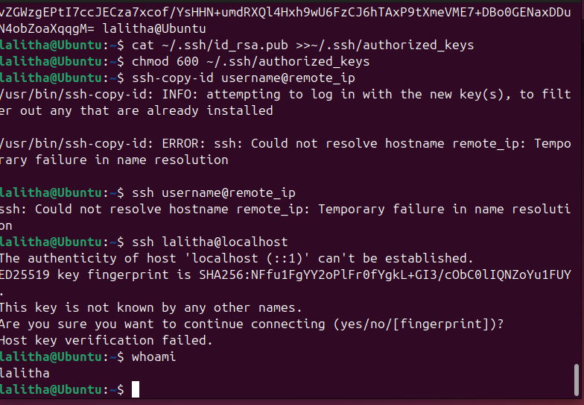

Task 25 : Monitor log files using tail or grep.
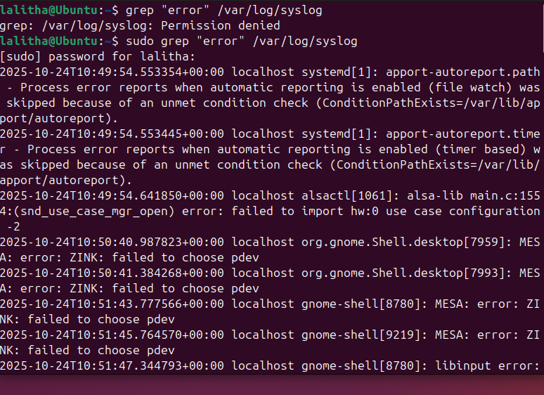
Task 26: Set up a web server (e.g., Apache or Nginx).
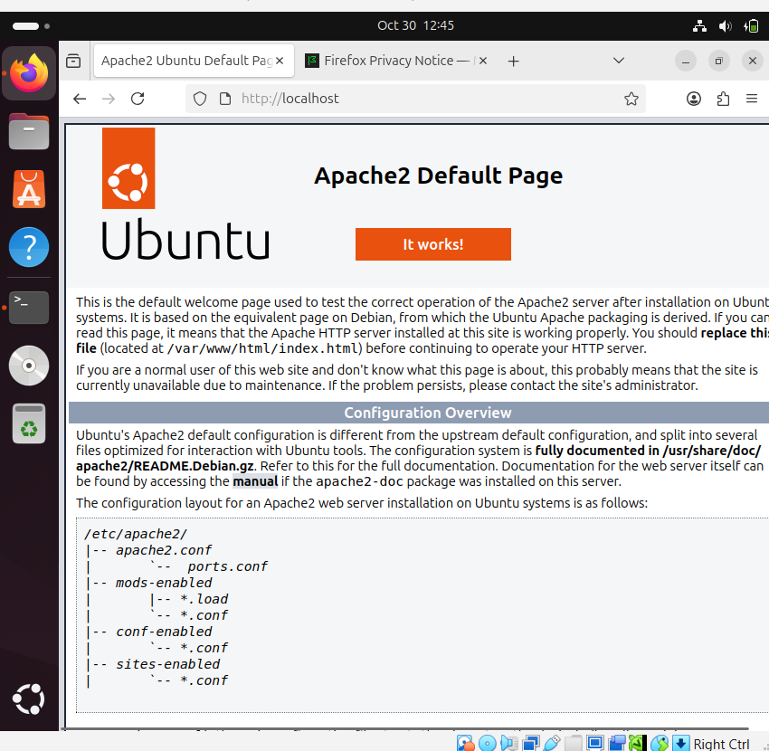
sudo apt update
sudo apt install apache2 -y
sudo systemctl start apache2
sudo systemctl enable apache2
sudo systemctl status apache2
in browser
http://localhost/
http://<your-ip-address>/
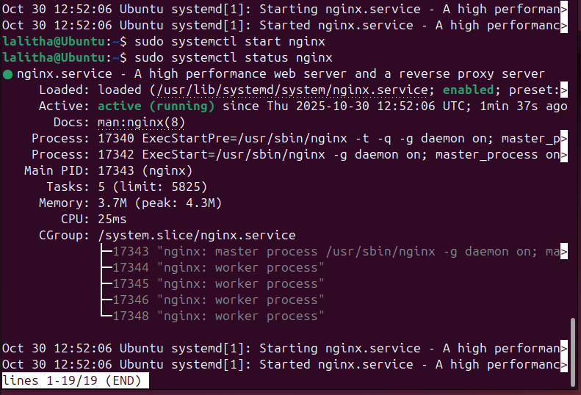
- Task 27: Configure and secure a MySQL Database.

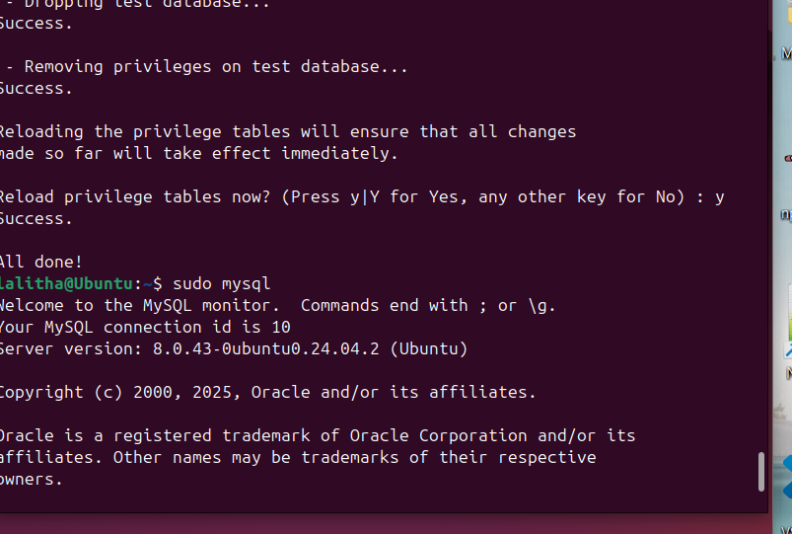

Task 28: Set up a Application Server (e.g.,Apache Tomcat)

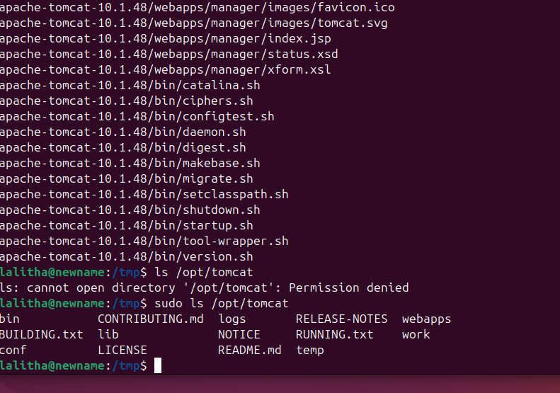
• Update system
sudo apt update -y
• Install Java
sudo apt install openjdk-17-jdk -y
• Create Tomcat user
sudo useradd -m -U -d /opt/tomcat -s /bin/false tomcat
• Download Tomcat
cd /tmp
wget https://downloads.apache.org/tomcat/tomcat-10/v10.1.31/bin/apache-tomcat-10.1.31.tar.gz
• Extract Tomcat
sudo mkdir /opt/tomcat
sudo tar -xvzf apache-tomcat-10.1.31.tar.gz -C /opt/tomcat --strip-components=1
• Give permissions
sudo chown -R tomcat: /opt/tomcat
sudo chmod +x /opt/tomcat/bin/*.sh
• Start Tomcat
/opt/tomcat/bin/startup.sh
• Check if it’s running
Open your browser and go to:
👉 http://localhost:8080

Task 30 : Print specific columns from a delimited file.
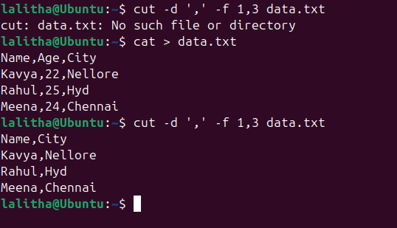
Task 31: Filter and print lines based on a specific pattern or condition.
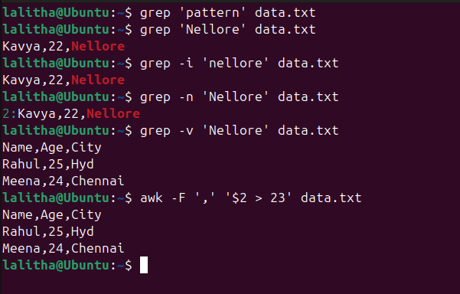

Task 32: Calculate and print the average, sum, or other statistics of a column.
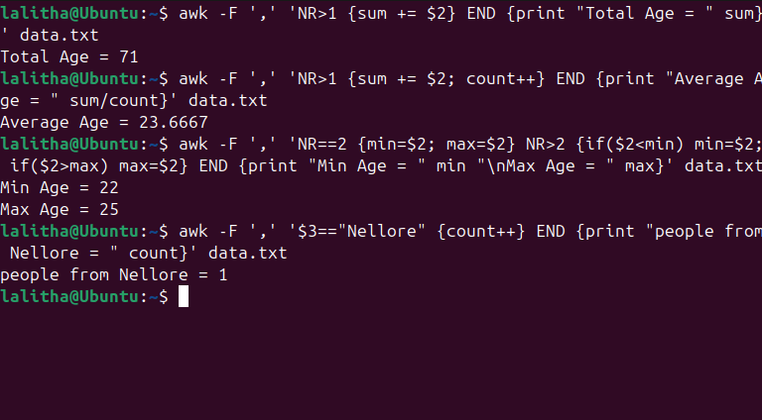Task: 33 Perform string manipulation, such as extracting substrings or changing case.

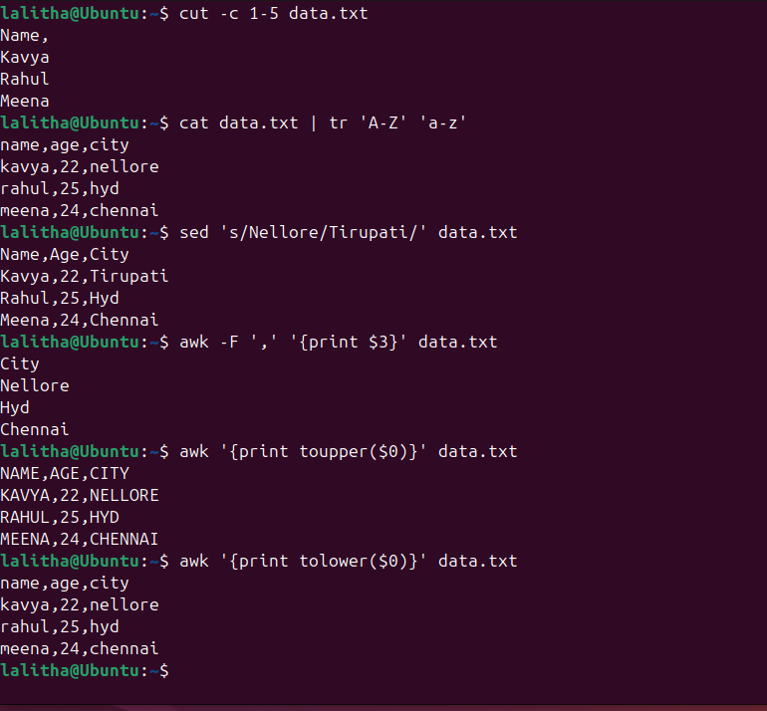
Task 34 : Count the occurrences of a specific pattern in a file.
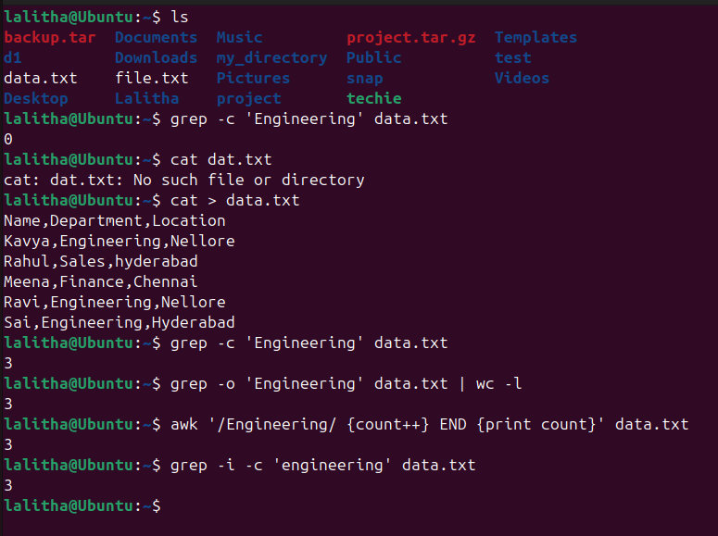
Task 35: Sort lines based on a specific field or column.
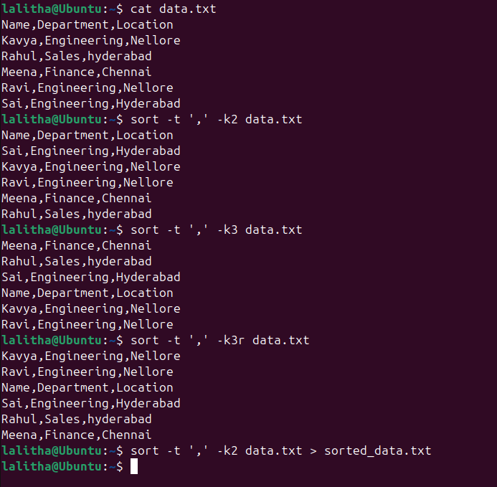
Task : 36 Merge multiple files based on a common field or column.
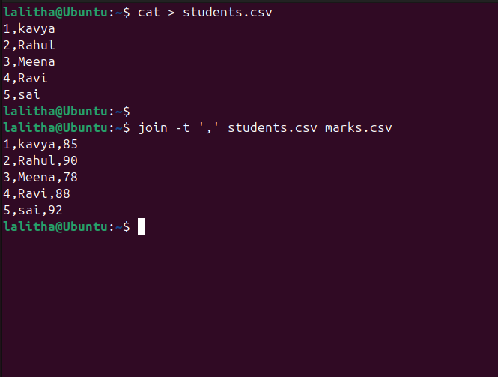
Task 37: Substitute text in a file using search and replace.
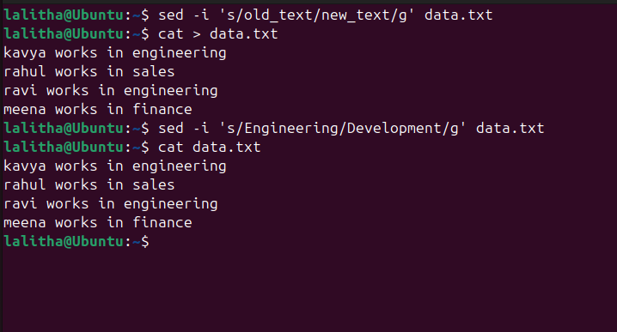

Task 38 : Delete specific lines based on a pattern or line number.
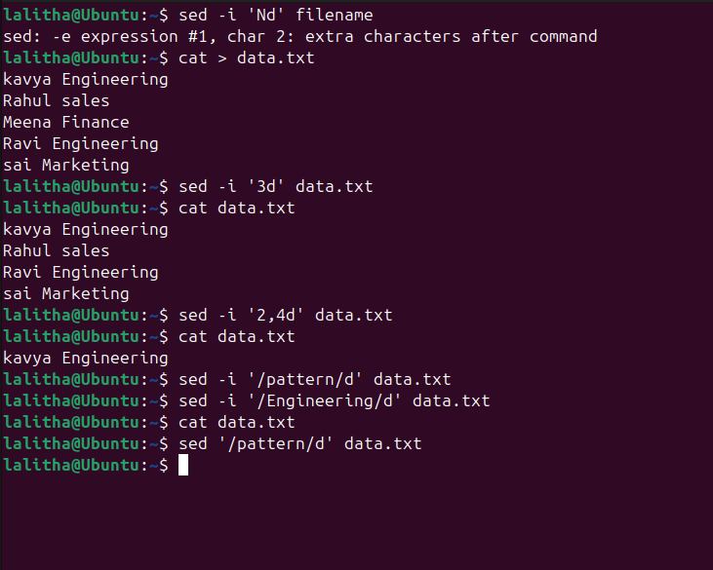
Task 39: Append or insert text before or after a specific pattern or line.
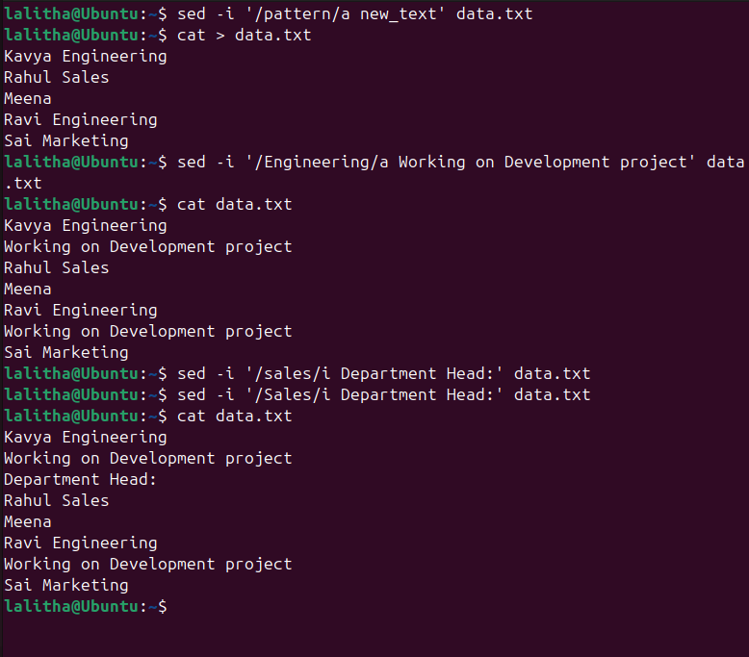
Task 40 : Print only specific lines from a file.
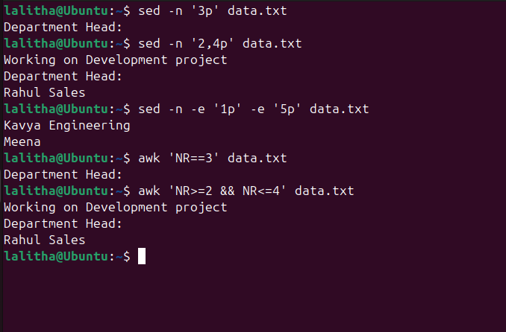

Task:42 5 use cases for AWK and 5 use cases for sed
